First Name Last name
Student-class-information
Title of Paper
Thesis statement: One complete sentence go here.
I. Major point 1 supporting thesis
A. Second level point supporting major point 1
B. Another second level point supporting major point 1
1. Third level point supporting second level point
2. Another third level point supporting second level point
a. Fourth level point supporting third level point (Comparison/Contrast Only)
b. Another fourth level point supporting third level point (Comparison/Contrast Only)
3. Another third level point supporting second level point
C. Another second level point supporting major point 1
II. Major point 2 supporting thesis
[repeat pattern above with as many levels and points as needed]

- The topic headings should reflect the actual content of your notes and ideas.
  - Do not use the terms "introduction" or "conclusion"; instead, use "Significance of rehabilitation" or "History of lotteries" or "Patterns of abuse."
  - Do not use "example" or "case study"; instead, use "Norfolk jail's program" or "Colonial lotteries" or "the Newport News case."
- Use one of the three major types of outline consistently.
  - Topic outline: In this most common and often preferred type of outline, each entry is a noun, noun phrase, or noun substitute (no verb phrases, no complete sentences).
    - Capitalize only the first word of each entry (except for proper nouns).
    - Use parallel structure within each subdivision.
  - Sentence outline: Some scholars prefer the completeness of a sentence outline in which each entry is a complete sentence. However, sentence outlines are more difficult to revise if you decide to reorganize.
  - Paragraph outline: Used primarily for long papers, the paragraph outline has a paragraph for every entry except for headings.
h. After you have drafted your outline, review it for logical organization and for accurate reflection of the subject.
The following example illustrates a formal topic outline with page format set up according to MLA guidelines (see Guidelines for Academic Papers for details).
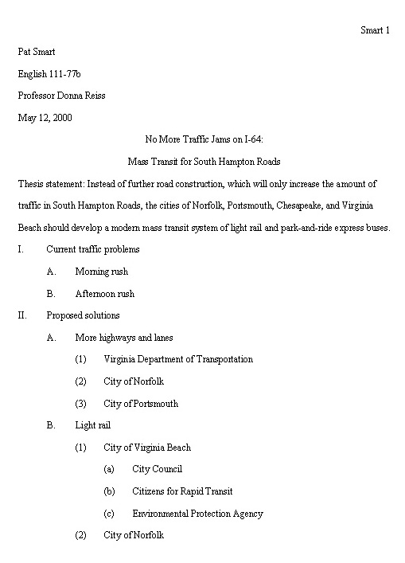
for educational purposes only
developed and copyright ©May 2001 by D. Reiss
modified and copyright ©8 March 2003 by D. Reiss

