The McCarthy Hearings and their relation to the Salem Witch Trials

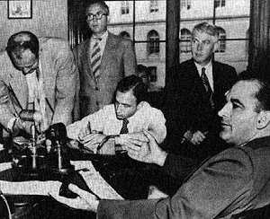
Background Information
» The McCarthy hearings were trials in which Senator Joe McCarthy accused government employees of being Communists. He exaggerated and exploited the evidence and ruined many reputations. Blacklists were created and many employers refused to hire the suspected or accused. (If they did then they would be accused.) Due to the exaggerated evidence and the seriousness of the charges, the hearings struck fear in many Americans. Although at first popular, the public began to wonder how far it would go. After McCarthy accused the U.S. Army of housing Communists, his committee began to go down hill. The army strongly defended themselves as they sought to end McCarthy's "witch-hunts." In November of 1954 the Watkins committee censured McCarthy under two counts. The Senate voted to "condemn" him on December 22, 1954. This censure ended McCarthyism but could never undo all of the damage that it had caused.
Parallels between the Salem witch trials
» The McCarthy Hearings were referred to as "witch-hunts" because of their similarity to the Salem witch trials. They both struck fear in the people due to the "guilty until you confess" attitude which ruled the courts. In Salem the only way to escape death was to confess and repent; in the McCarthy hearings if you were accused, whether guilty or not, you would always be viewed as a Communist. McCarthy also relates to Abigail in The Crucible, because they both made false accusations against innocent people. McCarthy accused people of being communists, whereas Abigail accused people of being witches. Philosopher George Santayana best states McCarthy's fatal error - "Those who cannot remember the past are condemned to repeat it."

Salem Witch Trials | The McCarthy Hearings
» 1692  » accused of being witches  » resulted in the execution of 20 people  » forever damaged reputations  » began by young girls  » speculated cause: land disputes  » some farmers raised chickens  » "witches" were scapegoats for all the problems  » accuser was highly respected  » untrue accusations | » 1950's  » accused of being communists  » resulted in no direct deaths  » also damaged reputations  » began by McCarthy  » speculated cause: to promote campaign  » McCarthy had 12,000 chickens by age 16  » "communists" were scapegoats for society's problems  » McCarthy was also highly respected  » untrue accusations

